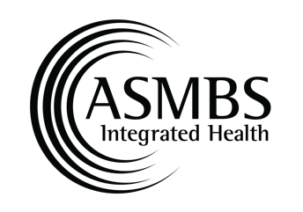

Distinguished Advanced Practice Provider Award Nomination Form

The Distinguished Advanced Practice Provider Award recognizes an exceptional advanced practice provider in the field of metabolic and bariatric surgery. This award is bestowed upon individuals who have significantly contributed to advancing the practice and role of advanced healthcare providers within the specialty, going above and beyond their duties in the multidisciplinary team or program.

To nominate a colleague please email this nomination form to jennifer@asmbs.org .

Nominator Information
Last Name: | First Name:
MBS Program/Facility:
Phone Number: | Email:

Nominee Information
Last Name: | First Name:
MBS Program/Facility:
Phone Number: | Email:

Type of Advanced Practice Provider:
Nurse Practitioner | Physician Assistant | Clinical Nurse Specialist

Criteria (Please check all applicable criteria):

Personal Qualifications:
An ASMBS member in good standing
Participates or has participated at a visible level within the ASMBS (see below)
Dedicated and loyal service to the Integrated Health Sciences Section
Respected and admired.
Compassionate
Other:

Actively involved in the American Society for Metabolic and Bariatric Surgery:
Committee and/or task force member
Professional Networking Group leader
Other

Demonstrates clinical excellence and leadership in metabolic and bariatric surgery through:
Provides competent and compassionate care to the bariatric surgery patient and population affected by obesity.
Collaborates with other members of the Integrated Health team to provide and promote high quality care to the metabolic and bariatric surgery patient.
Participates in the field of research related to metabolic and bariatric care, quality improvement studies; authors or co-authors articles, manuscripts, participates in literature review, evidence-based protocols, guidelines, or position papers.

Contributes to the education of metabolic and bariatric surgery professionals, especially advanced practice healthcare providers:
Educational presentations at seminars and/or conferences.
Published or other activities related to increasing the competency for colleagues and knowledge of the care of metabolic and bariatric surgery patients and families.

Participates in the community-local, regional, state or national-to advocate for metabolic and bariatric surgery efforts, such as access to care.
Yes
No

Narrative- 250-word limit (please include any other relevant information about the nominee):

Optional: Please feel free to attach any supporting documents and/or provide a link to supporting documents to submit your nomination.

