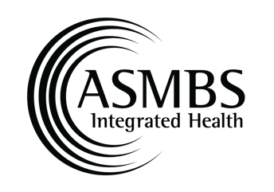

Circle of Excellence Award Nomination Form

The true strength of our Society is in the support, dedication, and talent of its membership. The Integrated Health Executive Council (IHEC) and the American Society for Metabolic and Bariatric Surgery (ASMBS) recognize that members practicing in the field of metabolic and bariatric surgery deserve recognition for the dedication, commitment, care and expertise they provide to patients, families and colleagues every day. The Circle of Excellence (COE) Award is given to a deserving provider who exemplifies compassion and dedication to care of the metabolic and bariatric surgery patient, as well as executes the visions and goals of the integrated health science section.

To nominate a colleague please email this nomination form to jennifer@asmbs.org .

Nominator Information
Last Name: | First Name:
MBS Program/Facility:
Phone Number: | Email:

Nominee Information
Last Name: | First Name:
MBS Program/Facility:
Phone Number: | Email:

Type of ASMBS Membership:
Regular | Regular Physician | Affiliate Surgeon
Affiliate Physician | International | Candidate
IH Regular Associate | IH Associate | IH International Associate
IH Affiliate | IH International Affiliate | IH Student

Type of Healthcare Provider:
Surgeon/Physician | Advanced Practice Provider | Behavioral Health Provider
Dietitian | Exercise Physiologist | Nurse
Other

Criteria (Please check all applicable criteria):

Personal Qualifications:
An ASMBS member in good standing
Participates or has participated at a visible level within the ASMBS (see below)
Dedicated and loyal service to the Integrated Health Sciences Section
Respected and admired.
Compassionate
Other:

Education Criteria:
Contributed educational content to Integrated Health Section Meetings, such as ASMS Weekend and/or the ASMBS Annual Meeting. Content may be in the form of presentations or participation in the planning and development of educational courses.
Effectively served and actively participated on an ASMBS Integrated Health Section Committee (specify committee(s):
Other

Research Criteria:
Contributed to the Surgery for Obesity and Related Diseases (SOARD) the official scientific journal of the ASMBS or an equivalent.
Presented an abstract at the annual meeting.
Awarded an ASMBS Integrated Health Research Grant.
Other

Patient Criteria:
Provides excellent care, which significantly impacts the patient.
Other

Public Awareness Criteria: Contributed significant effort in planning, developing, and/or implementing the following:
Development or involvement in public programs (support groups, exercise groups, etc.)
Development of patient educational materials.
Participated in access to care activities (Hill visits, letters to congressmen, etc.)
Organized a Walk for Obesity Event
Other:

Narrative- 250-word limit (please include any other relevant information about the nominee):

Optional: Please feel free to attach any supporting documents and/or provide a link to supporting documents to submit your nomination.

