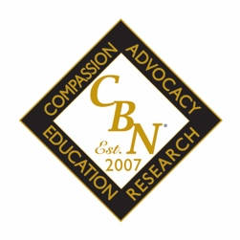

Distinguished CBN Award Nomination Form

The Certified Bariatric Nurse Committee and the American Society for Metabolic and Bariatric Surgery (ASMBS) believes Certified Bariatric Nurses (CBNs) deserve recognition for all they do every day for patients, families, the community, and our profession. That is why we honor our CBNs through the Distinguished CBN Award.

To nominate a colleague please email this nomination form to jennifer@asmbs.org .

Nominator Information
Last Name: | First Name:
MBS Program/Facility:
Phone Number: | Email:
Are you a CBN (It is not required that a nominator be a CBN). Yes No

Nominee Information
Last Name: | First Name:
MBS Program/Facility:
Phone Number: | Email:

Explanation (please limit responses to 500 words or less):
- Please describe how the candidate promotes compassion.
- Please describe how the candidate participates and promotes advocacy.
- Please describe how the candidate is involved in research.
- Please describe how the candidate is involved in education.

Optional: Please feel free to attach any supporting documents and/or provide a link to supporting documents to submit your nomination.

