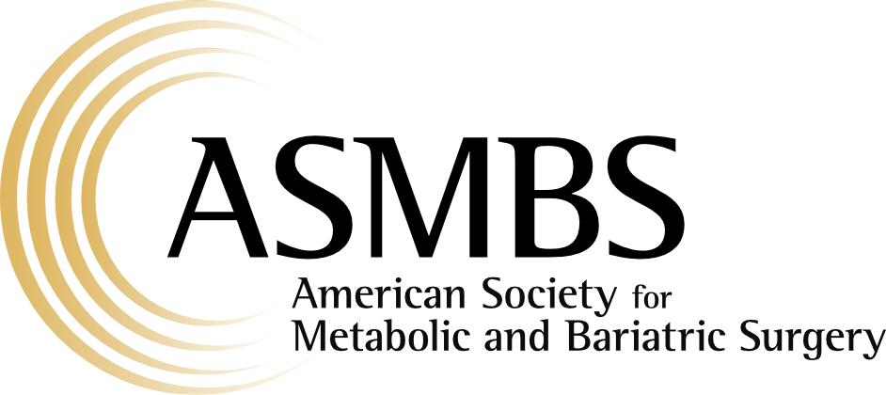
Program Director Attestation
for the ASMBS Fellowship Certificate Application

Integrity Statement
By submitting this form you attest that the information in the application is true and accurate to the best of your knowledge. It is the program director’s responsibility to act with integrity, and the burden is on you to ask questions if anything about the application requirements is unclear. The Code of Ethics of the American Society for Metabolic and Bariatric Surgery is intended as a guide to assist all members of the Society in achieving the highest level of ethical conduct in their relations with patients, peers and the public.

Fellow Full Name & Credentials:

Program Director Information
First name:
Last name:
Credentials:
Address:
City, State, Zip Code:
Telephone:
Email:
Fellowship Council Identification Number:
(Please contact your program fellowship coordinator if you do not know what this is)

Program Director Attestation
As the Program Director for the fellow named above, I certify the following:
Please initial each statement.

I confirm that the fellow successfully completed the fellowship training requirements and Core Curriculum established for the ASMBS Bariatric Fellowship Certificate, found at https://asmbs.org/professional-education/fellowship

I confirm that the fellow satisfactorily met the clinical, technical, and educational expectations of our fellowship program.

I confirm that I conducted at least two fellow performance assessment interviews during the fellowship training period.

I certify that this attestation has been completed with integrity and professionalism in accordance with the ASMBS Code of Ethics.

Fellow Performance Assessment Interviews
The ASMBS Fellowship Certificate Training Requirements require the Program Director to conduct at least two fellow performance assessment interviews during the fellowship. Please provide a brief synopsis of each interview, including general comments regarding the fellow’s progress, strengths, areas for continued growth, and readiness for independent practice.

Fellow Performance Assessment Interview #1

Fellow Performance Assessment Interview #1

Program Director Certification
I certify that the information provided in this attestation is true and accurate to the best of my knowledge. I understand that this document will be submitted as part of the applicant’s ASMBS Bariatric Fellowship Certificate application.

Program Director Signature:
Printed Name:
Date:

