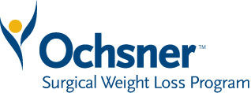

2020

Weight Loss Surgery Seminars

5:30 PM – 7:00 PM

Tuesday, January 21

Tuesday, February 18

Tuesday, March 24

Thursday, April 23

Tuesday, May 19

Tuesday, June 16

Tuesday, July 21

Tuesday, August 18

Tuesday, September 15

Tuesday, October 20

Thursday, November 17

Thursday, December 15

**Seminars are held in the Brent House Conference Center 2nd floor**

**Caldwell and Burns Rooms**

**Please call (504) 842-2701 to Schedule Seminar**

