[ASBP Blue on Transparent Background Logo.eps](http://www.asbp.org)[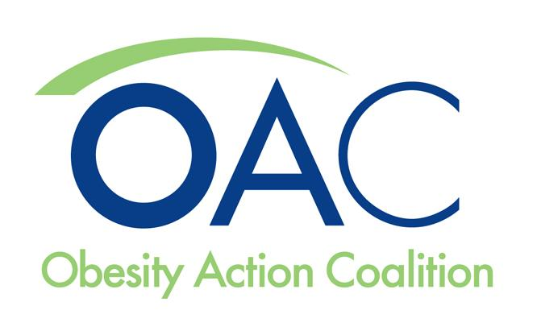](http://www.obesityaction.org)[Academy_of_Nutrition#E6C256.eps](http://www.eatright.org/)[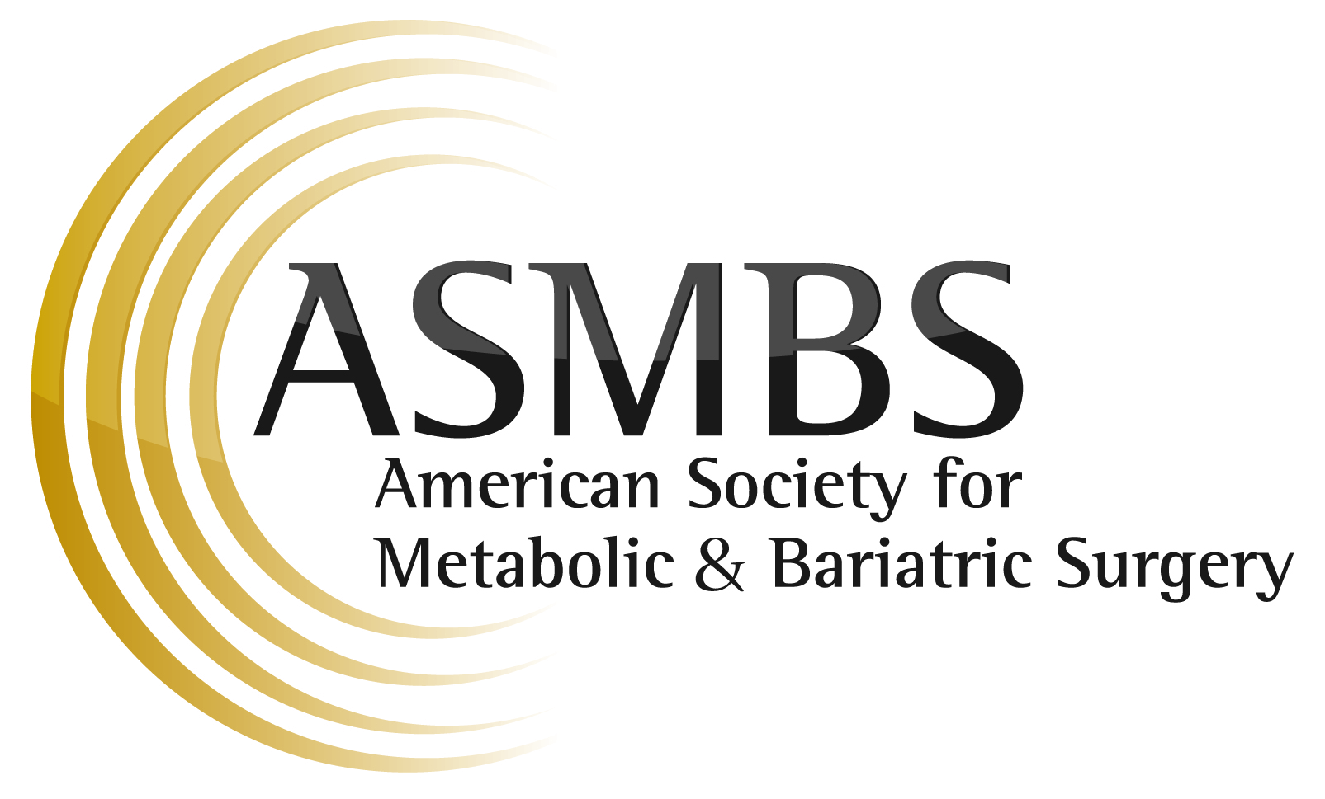](http://www.asmbs.org)[](http://www.obesity.org)j

Obesity Care Continuum: Promoting Coverage of Obesity Treatment Services – 2014 Advocacy Efforts

ESSENTIAL HEALTH BENEFITS

The Obesity Care Continuum (OCC) continued its campaign to secure state health exchange coverage for all evidence-based obesity treatment services. In a three-pronged offensive, OCC member groups are targeting the media, legislative and regulatory policymakers at the federal level, and key decision makers in state health exchanges across the country.

The Obesity Care Continuum was established in 2011 and currently includes the Obesity Action Coalition, The Obesity Society, the Academy of Nutrition and Dietetics, the American Society for Metabolic and Bariatric Surgery, and the American Society of Bariatric Physicians. With a combined membership of over 125,000 healthcare professionals, researchers, educators and patient advocates, the OCC is dedicated to promoting access to, and coverage of, the continuum of care surrounding the treatment of overweight and obesity.

On the federal regulatory front, the OCC continues its four-year dialogue with the Department of Health and Human Services (HHS) to address major gaps in obesity treatment coverage that are evident in a majority of state health exchanges. Most recently, these efforts have focused on providing HHS with clear examples of qualified health plans (QHPs) employing discriminatory benefit design language targeting obesity treatment – in states that have already declared bariatric surgery to be a covered service under their state health exchange plan. Discussions focused on surgery as “weight loss programs” and “bariatric surgery” are the only obesity related terms that can be tracked in QHP Summary of Benefits and Coverage forms.

**Summary of Coverage of State Health Exchange Essential Health Benefit (EHB) Benchmark Plans**

Twenty-two states chose benchmark plans that cover bariatric surgery (AZ, CA, DE, HI, IL, IA, ME, MD, NV, NH, NJ, NM, NY, NC, ND, MA, MI, RI, SD, VT, WV and WY).

Five states chose benchmark plans that cover weight-loss programs (CA, DC, NM, MA and MI).

Twenty-eight states chose benchmark plans that cover neither bariatric surgery nor weight-loss programs (AL, AK, AR, CO, CT, FL, GA, ID, IN, KS, KY, LA, MN, MS, MO, MT, NE, OH, OK, OR, PA, SC, TN, TX, UT, VA, WA, WI)

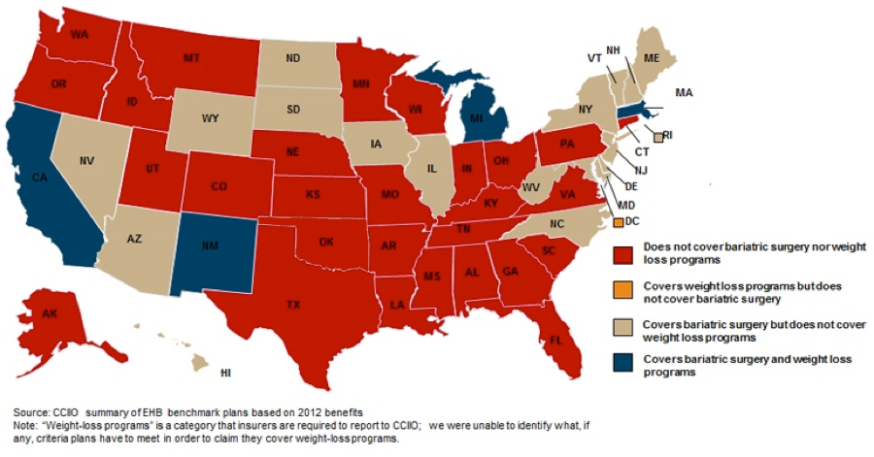

For example, a number of QHPs in California, Michigan, New Mexico and New York either outright exclude bariatric surgery coverage, limit patients to one procedure per lifetime or employ prohibitive patient cost sharing – as high as 70 percent for patients seeking bariatric surgery. And in one of the most egregious examples – the OCC has identified QHPs in states such as Kentucky and Missouri that not only exclude coverage for bariatric surgery but also prohibit coverage for any perceived complications that may be related to a patient’s previous bariatric surgery covered under a prior carrier or self-funded plan. Despite these clear violations of Affordable Care Act patient protections (pre-existing condition clauses, lifetime limits and discriminatory benefit design language) HHS continues to side step its oversight authority in favor of letting states work out these issues – instructing advocates to contact state insurance commissioners for any kind of recourse.

These latest developments signaled that it was time for the obesity community to go back to Capitol Hill in hopes of a legislative remedy. While most congressional offices had no desire to engage in a discussion about a legislative mandate for covering obesity treatment, they were intrigued by recent activity over at the Office of Personnel Management (OPM). Earlier in the year, OPM issued specific guidance to both Multi-State Health Plans and Federal Employee Health Benefit Program carriers regarding obesity treatment services – stating that the agency will no longer tolerate plans excluding obesity treatment coverage on the basis that obesity is a "lifestyle" condition or that treatment is "cosmetic."

In sharing this news on Capitol Hill, the OCC found that many offices were both appreciative of OPM’s leadership on this issue and also a little concerned about the public perception of federal employees receiving access to obesity treatment coverage protections not afforded to the millions of Americans in state health exchange plans. These feelings led both Representative Eddie Bernice Johnson (D-TX) and Representative Earl Blumenauer (D-OR) to initiate a congressional sign-on letter to HHS Secretary Sylvia Burwell – urging the Department to follow OPM’s lead and issue similar guidance on obesity treatment coverage to state health exchanges. Representatives Johnson and Blumenauer and 47 other House Members signed on the final letter.

OCC member groups were joined by 10 other national healthcare professional and patient organizations in supporting a full-page advertisement in the Capitol Hill newspaper Roll Call during the week that Representatives Johnson and Blumenauer released their congressional sign-on letter. The ad questioned why state health exchanges were discriminating against obesity treatment – highlighting how over half the state health exchanges in the country exclude coverage for bariatric surgery and only a handful provide coverage for evidence-based weight loss programs or FDA-approved obesity drugs.

The OCC correctly believed that the ad would be a great catalyst for securing strong support on the Johnson/Blumenauer letter by shedding sunlight on the unequal coverage standards for obesity compared to other chronic disease states. In addition, the obesity community sought to build on the momentum of the American Medical Association’s (AMA) recent adoption of policy stating that obesity is a disease and that the AMA "supports patient access to the full continuum of care of evidence-based obesity treatment modalities such as behavioral, pharmaceutical, psychosocial, nutritional, and surgical interventions."

The success of this latest advocacy campaign on Capitol Hill could be a tremendous help to obesity advocates on the state level should HHS choose to follow OPM’s footsteps – requiring that qualified health plans provide a compelling rationale for excluding coverage for evidence based and medical necessary obesity treatment services. Such guidance from HHS could be a powerful weapon in calling out health plans that wish to continue biased and discriminatory coverage practices against the millions of Americans affected by obesity.

*For more information about the Obesity Care Continuum, please contact OCC Washington Coordinator Christopher Gallagher at 571-235-6475 or via email at chris@potomaccurrents.com.*